# 

# Week 10: Coursework

## Angular Framework

1. Create a new Angular application using Angular CLI. This application will calculate the roots of a quadratic equation as we did in the Spring framework coursework number six.
2. Create a *calculator* component using Angular CLI and associate it to the root component (App Component)
3. In the *calculator’s* component HTML template, you have to create the following:
   1. Five HTML *<input type=”text”>*, three to input the equation’s variables and two to display the calculated equation’s roots.
   2. An HTML button to trigger the calculation.
   3. Use the figure below as a reference.
4. 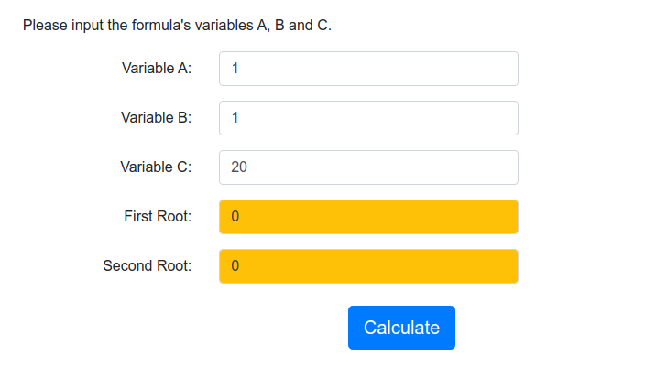In the *calculator’s* component TS file, you have to create the following:
   1. Five numeric variables associated using two-way binding to the HTML *<input type=”text”>* specified in step four. Hint: Use *[ngModel]*. Also, add the *FormsModule* to the application’s *AppModule* *imports* array to enable *[ngModel]* in the application.
   2. A method called on*Calculate*() that implements the business logic to find the equation’s roots. The method is triggered by the HTML button using *event* *binding*.

A quadratic equation has two solutions or roots. We can find each root with the following formulas: 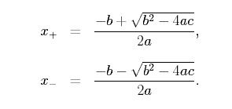

Before performing any calculation, ensure that the expression inside the square root is greater or equal to zero; otherwise, you will get an error.

So make sure that:

(b)² - 4(a)(c) >= 0

If the expression above is less than zero, assign 0 to both root variables, and console.log() “Equation has no real roots!”; otherwise, calculate and display the two roots (root1 and root2) and display "Calculation completed successfully!" using String Interpolation.

The Math library has the pow() method to help you with the calculation.

1. Add Bootstrap styles to make your application look more attractive.
2. After completing the project, test it, and create a new repository on GitHub, finally commit and push your application to GitHub.
3. You can find the solution for the project in the Github repo:

<https://github.com/busyQA-java-developer/busyqa-10-angular-2-coursework-complete.git>

// End